MULESOFT ANYPOINT PLATFORM
Experiment-1
Steps:
- Navigate to the mulesoft anypoint platform by navigating to it.
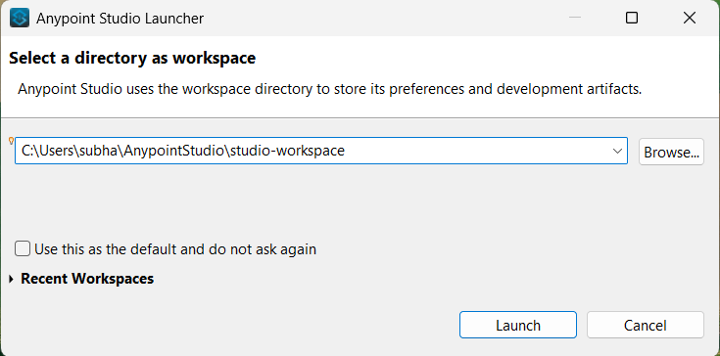

- After the software is launched, go to File → New → Mule Project. On doing so, a new dialog box for creating the mule project pops out.

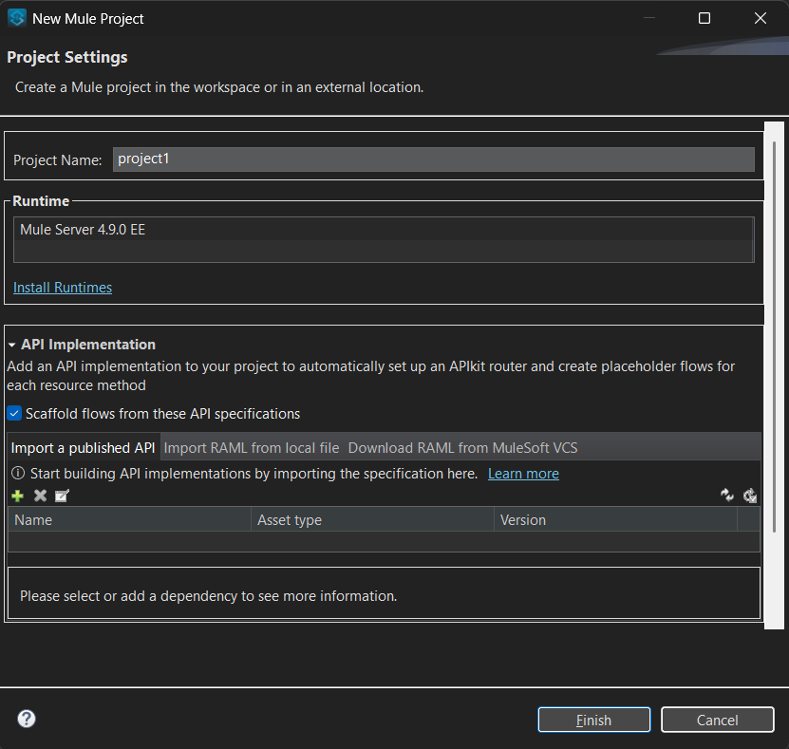
- Enter the Project Name and in the Project Location select the required location where the project has to be created and then click on Finish.
- Now, drag the Listener(HTTP) from the Mule palette on to the canvas.

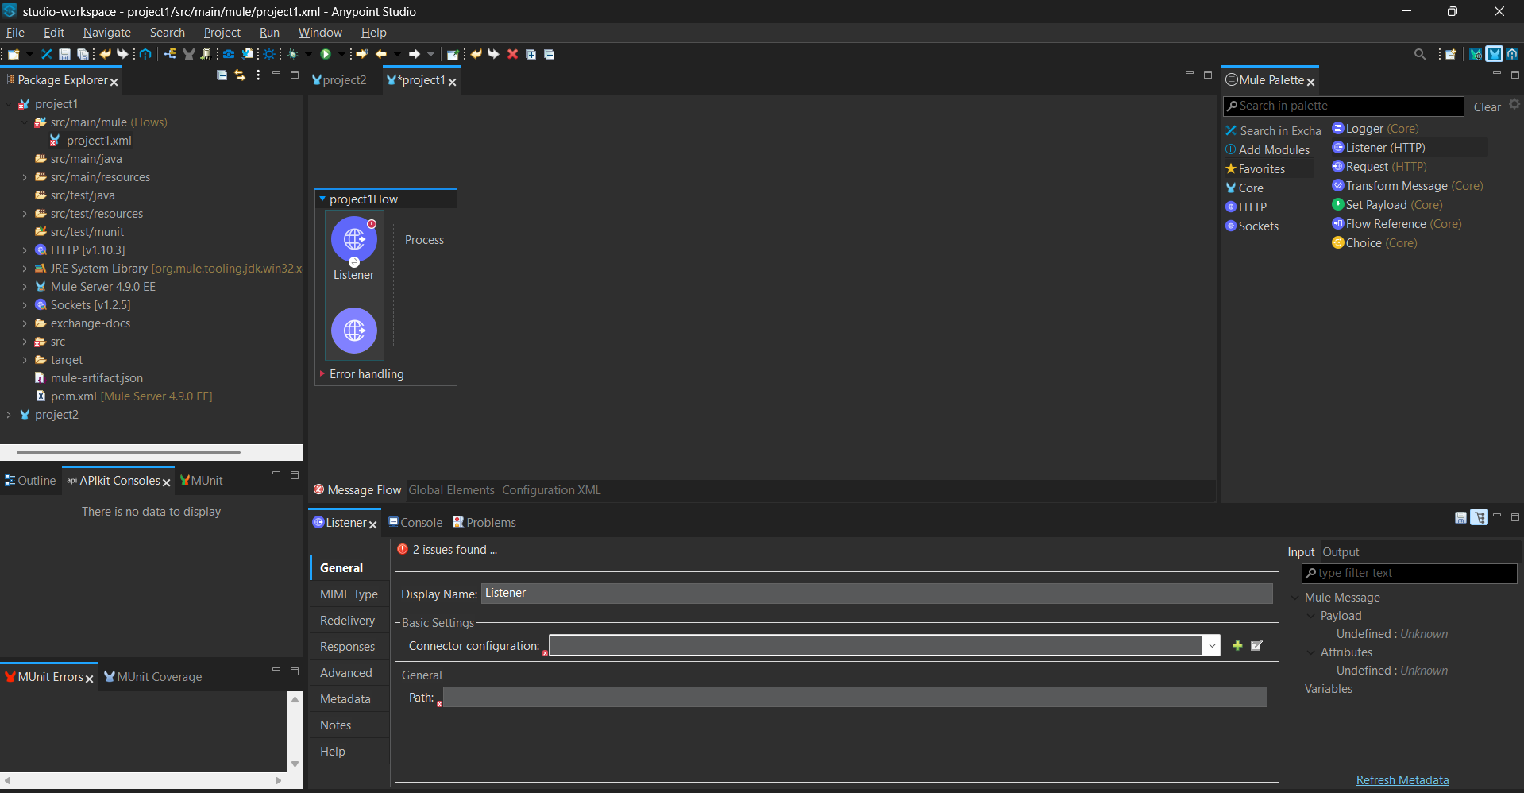

- Now to configure the required properties of the listener, we need to click on the listener and we find the message flow dialog opened.
- Now add the connector settings using the “+” button and define the required port number (8081), and click on ok.

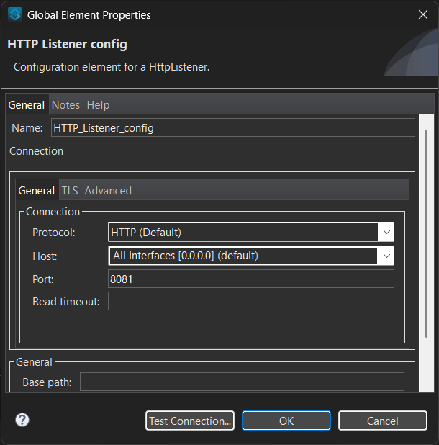
- Define the path by which we can access it from the server using the port number and path defined.
- Now drag the Transform Message from the Mule palette – Favorites to the project1Flow listener.

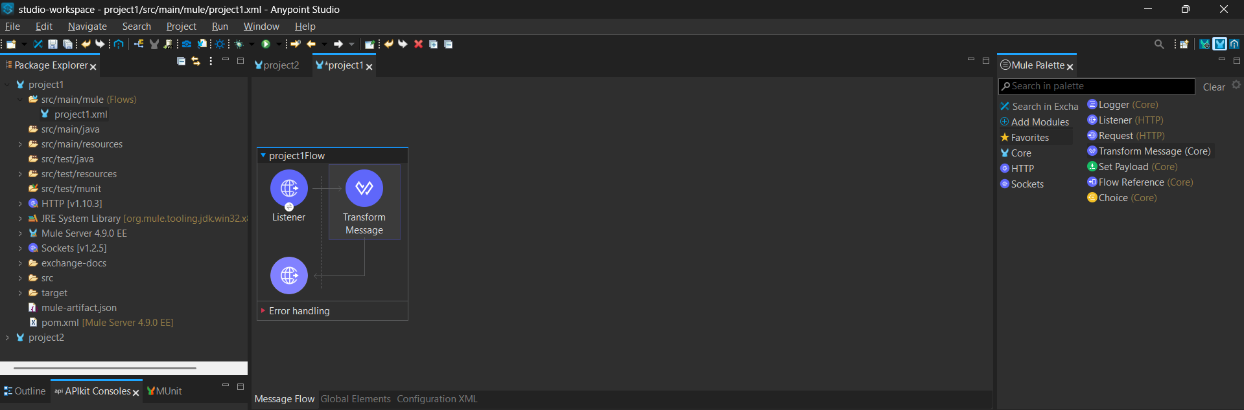

- Now click on the Transform Message and then add the required message and also the file format to be displayed as the output.
  - Ex : json format with the student details…
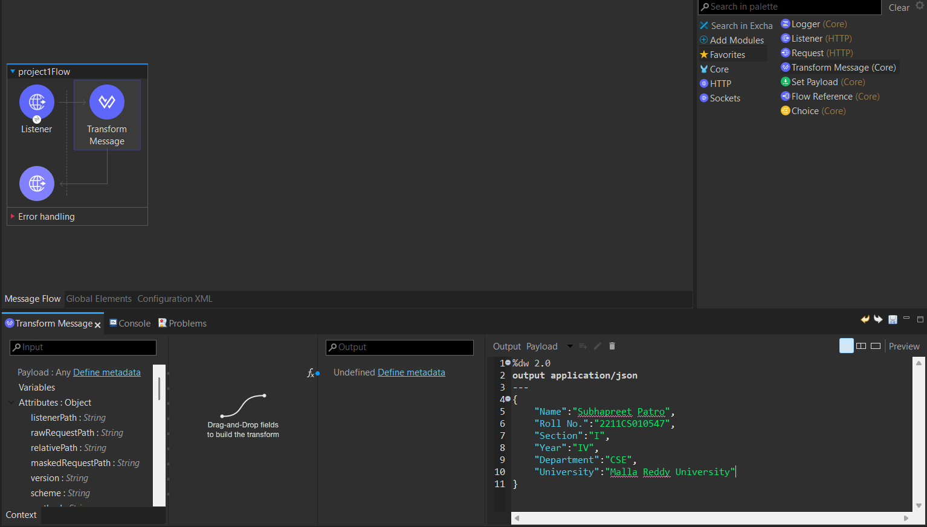
- Save the project and then right click on the canvas “Run project project1”.

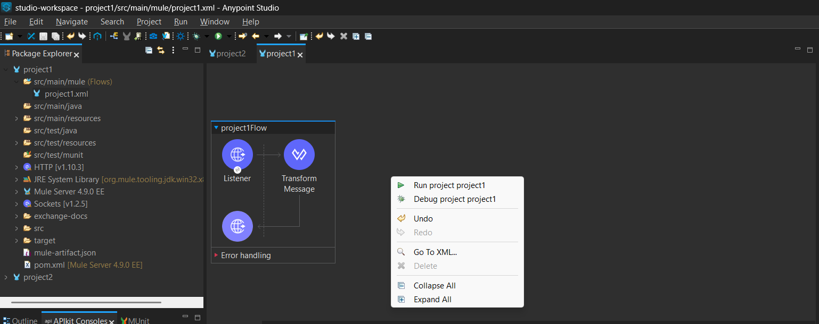

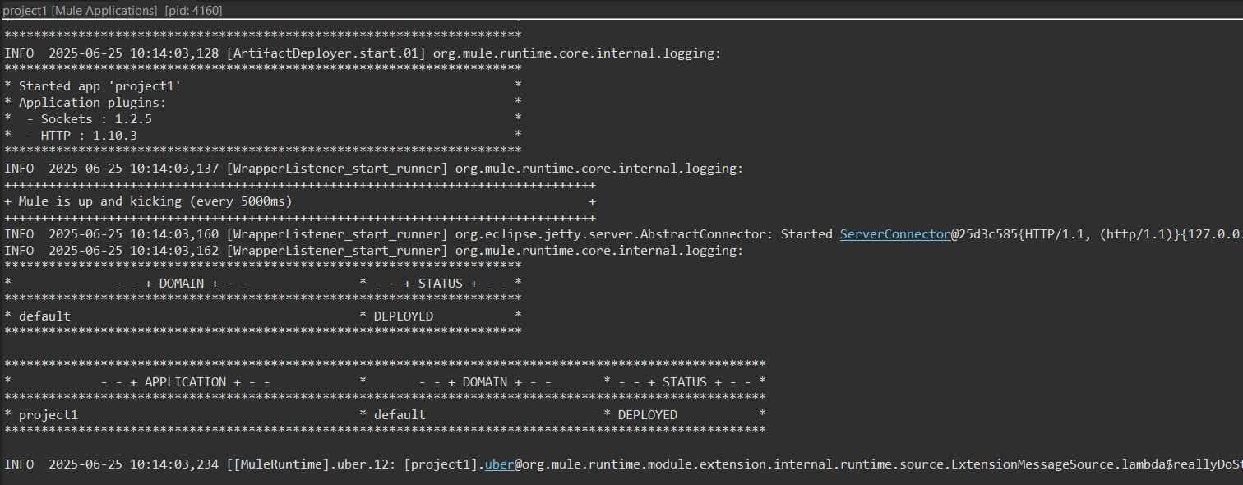

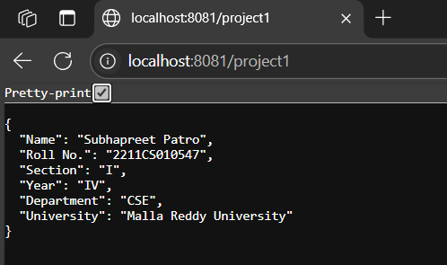

- Now the output given in the Transform Message is displayed on the localhost port number and specified path.

